**Customer App API Changes**

Base URL **:** [**http://103.253.15.102:88/mainapi_cloudtest/**](http://103.253.15.102:88/mainapi_cloudtest/)

**New Changes**

1. In order section: Need to change the name of title from Orders to my bookings

Solution : app side

1. On top of home page, there are promotional banners, in which multiple banners are

there but, only single image is showing instead of multiple images of banners

Solution : app side

1. On home page: there is Shop for products, and we’ve to change it’s title from Shop to

products and it should show on app

Solution : app side

1. For booking services we’ve to change the flow from directly purchasing the services and then from my bookings user can do bookings like Select services Select salon, Date, time and select staff. Screens and layout is working and API is working we just need to change the flow for service booking now

API : **bookAppointmentTncNew**

Changes : api name changed from **bookAppointmentTnc** to **bookAppointmentTncNew.**

No changes in input.

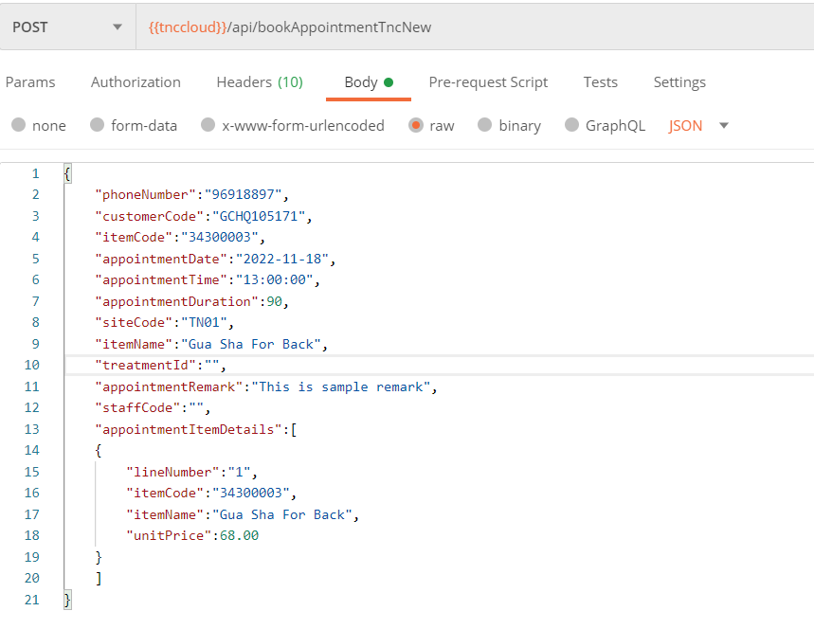

1. Notifications for Reward points earning from in-app, API is working from app side

the issue is there

Solution : app side

1. Invoice or order history, just after purchasing the service or products should be shown to customer

Note: New screen and flow need to be developed for invoicing and showing

purchase history

Solution : Api already available. API : **appTransSearchInvoiceDetail**

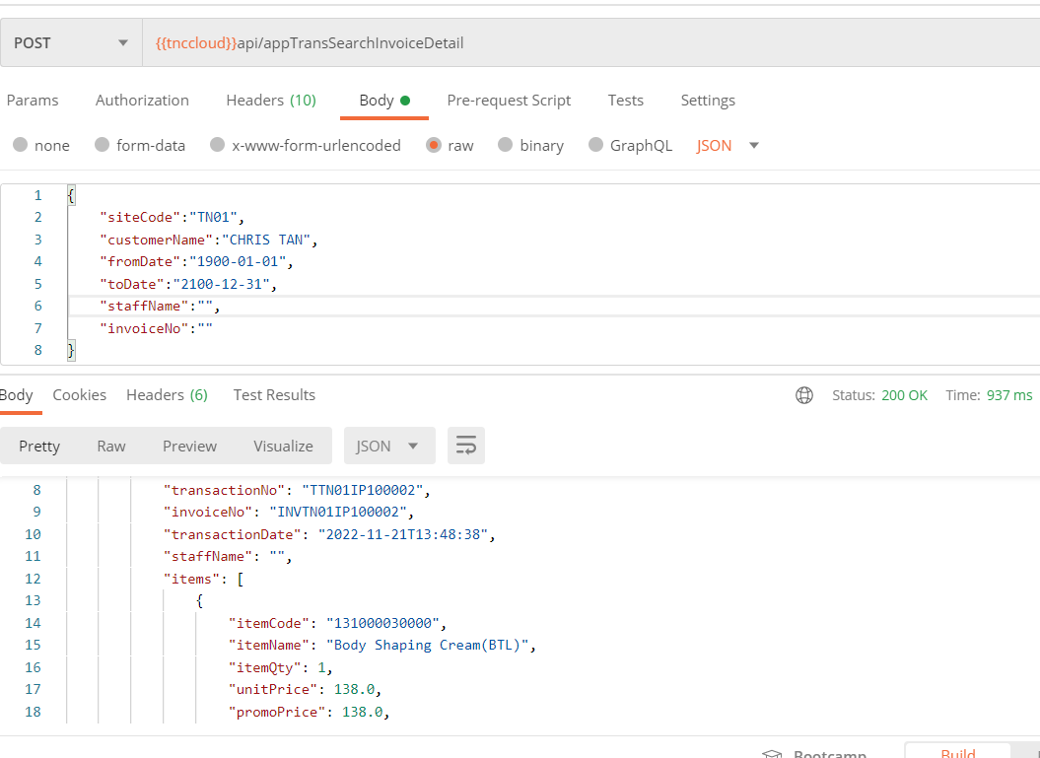

1. Hide Invitation section from My profile.

Solution : app side

1. Shipping for products is just self collect from salons, We need to hide other shipping

methods from the app.

Solution : app side

1. Strip payment gateway issue: Sometime payment gateway works sometimes it didn’t

showed up to make payment, or sometimes it just load

Solution : Api verified. No issues in api side.

1. In apple app, while login or registration, keyboard occurs issues

Solution : app side

1. Home page> Banners(Promotions)>Products>Product page> Product description> Add

to cart>Checkout> Payment> Order done>Earn rewards

Purchase done> Purchase invoice> My orders>Order on hold> Customer picked

up>sign> order done completed.

Order will be on hold in FE, and until customer comes to pickup the product and sign, order will be on hold status and once picked, orders status delivered or completed

Solution : API : **appTransPostSalesF21**

Changes : developer should pass below 2 input field value data additionally in transactionDetails array.

**"holdItemQty":1**

**"isHoldItem":true**

Should pass holdItemQty value same as **itemQty** field. And **isHoldItem** as **true**

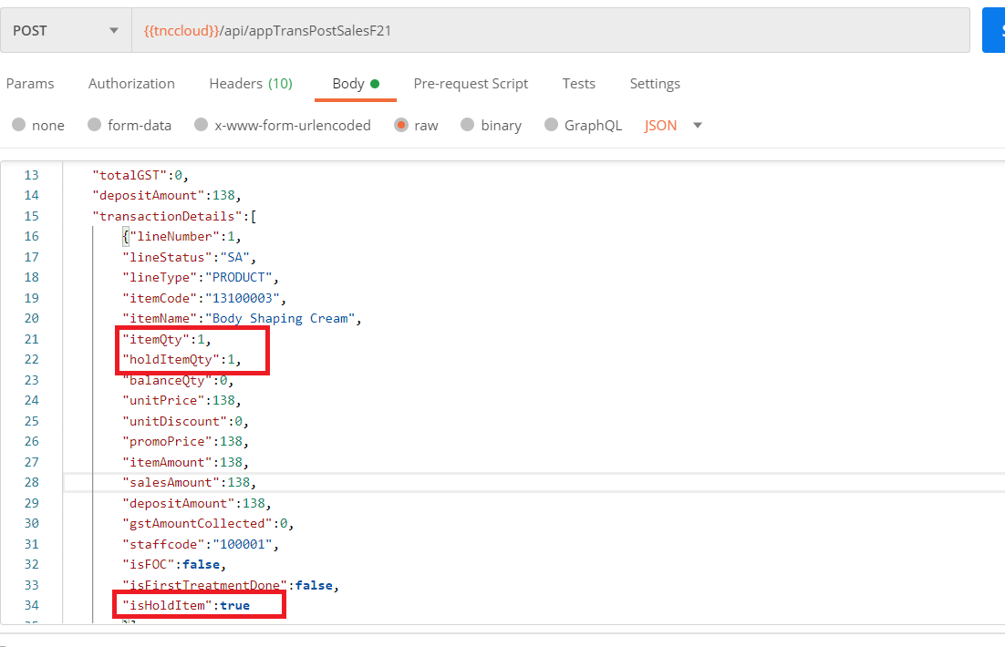

1. Flow for services:

Home page> Banners(Promotions)>Services>Service list> Service description> Service

package>Add to cart>Checkout> Payment> Order done>Earn rewards

Purchase done> Purchase invoice> My bookings>Book service>Service booked with

date, time, staff,service selection> Booking done

Solution : App Side.

1. New payment gateway integration: Enets(It’s a singapore based payment gateway)

Integration for enabling online debit/credit card and other payment options to make

payment for booking

Solution : app side. (let me know, if need any new api)

1. Bugs, errors or other issues, which are causing an fault to the app

Solution : App Side.

1. App theme: We need to change the theme, and put it in setting, where user can

change the theme from dark to light

Solution : App Side.